COMPUTER ORGAIZATION AND ASSEMBLY LANGUAGE
NAME:
MUHAMMA D TALHA
CLASS:
4/A
ROLL NUMBER:
241890
INSTRUCTOR:
MS ROMANA

CODE:
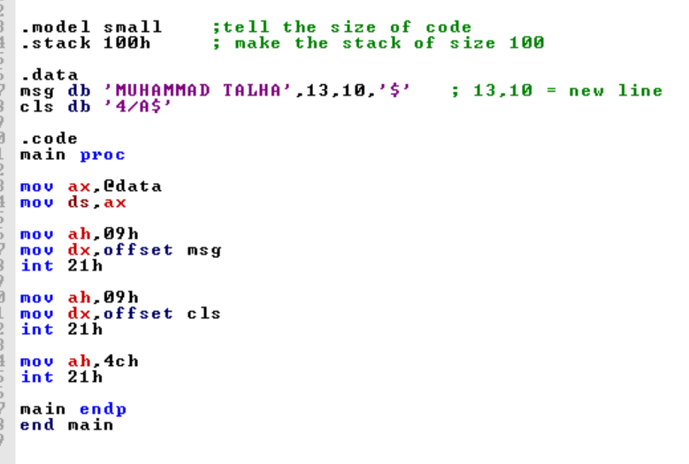

OUTPUT:
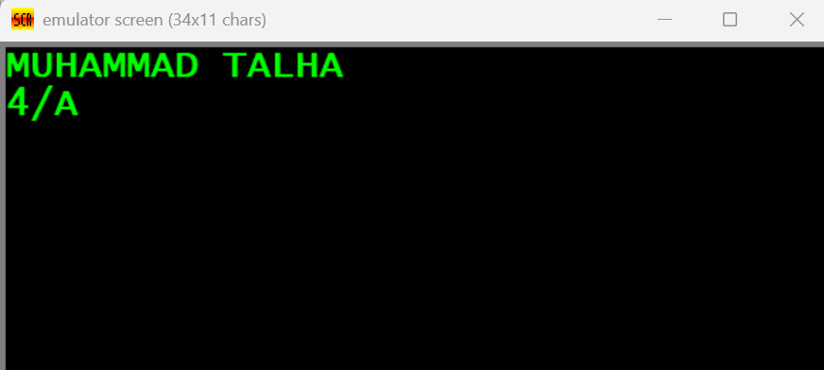

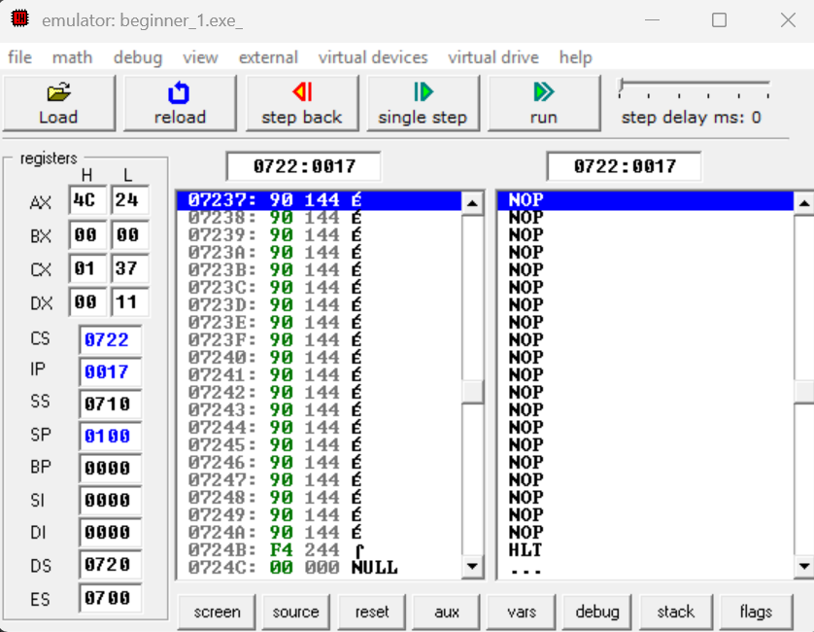
REGISTERS:

DEBUGGING:
